**ESXI VM SET UP**

1. **Create a network for GNS3 VMS configured as followed:**
2. 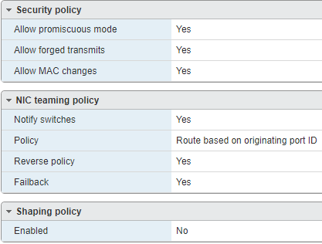
3. Go to <https://www.gns3.com/software/download-vm>
4. Chose VMware Workstation and Fusion download for the current version   
   *This will download a zip file with an OVA file
5. Use the OVA file to make one VM with the resources that you want allocated per 1 student/user
6. When you start the VM it should look like this 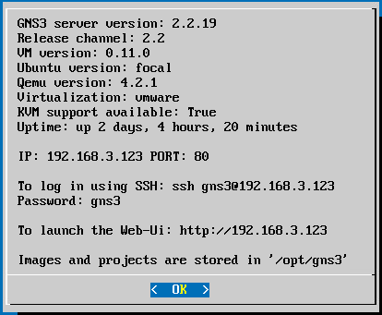
7. To set static networking hit enter or space to get to the menu
8. N to get to Network config file   
   *This will restart the VM after the file is saved
9. Network config files are pre-configured and commnted out for static configuration if desiered
10. Add appliance files to the VM threw direct download to the VM threw the Linux command line or through the GNS3 GUI
11. The ubuntu connsole can be accsesd with S
12. Then clone the VM or use it as a template for each student in the course

**INTERFACE**

**Home view:**

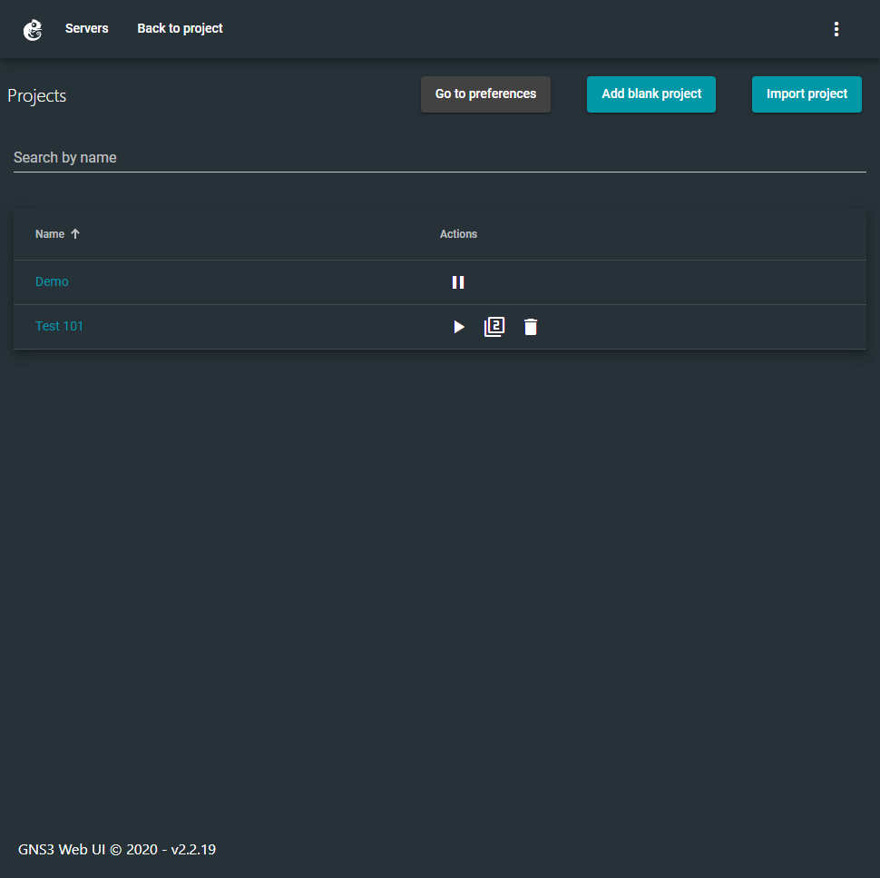

* To start a new project click add blank project
* Listed are the existing project on your server
* A Project is equivalent to one virtual environment
* Project nodes will continue to run even when you leave or close the page unless stopped or suspended
* You can suspend a project with the pause button (this will free up Virtual resources)
* If suspended, you can start it with the paly button duplicate it with the 2nd button and delete it with the 3rd button
* To open a project simply click its name

**Project view:**

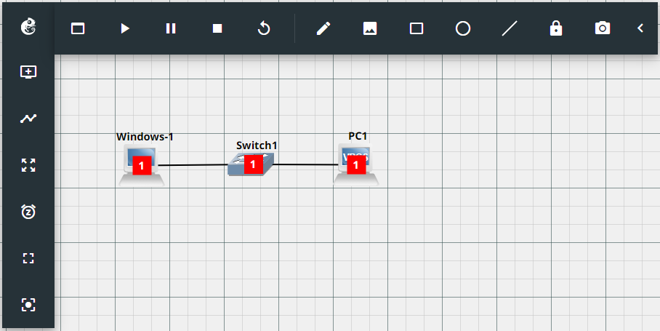**Top Row left to right:**

* GNS3 logo: opens a menu to navigate the server and change settings
* Console box: opens the web console to all active devices
* Play: Powers on all devices
* Pause: Suspends all devices
* Stop: Powers off all devices
* Reload: Dose a hard Reboot of all devices
* Pencil: allows the creation of a text box for notes
* Image: allows for the insert of images
* Shapes: allows you to draw a square circle or line respectively
* Lock: Locks the orientation of the network
* Camera: takes a screen grab of the network

**Left side bar top to bottom:**

* Add node: opens the drag and drop menu used to create new devices on your network
* Link: allows you to connect ports similar to Packet Tracer
* Moving mode: Enable/disables moving all nodes across the background instead of with it
* Clock: Take and Save snapshots of the network
  + I would suggest only doing this at the end of every lab as it dose take some time to take
* Fit view: Centers the view and size on the nodes
* Center view: Centers the view on the background

**Project:**

* Images: These are the virtual nodes that run on the network
* Thick Black line: This represents a hard network connection
* Red box with a number: This represents the Layer
* Grid: The project background

Individual Node manipulation (Menu opened via right click)  
*Some options may not be available on all devices

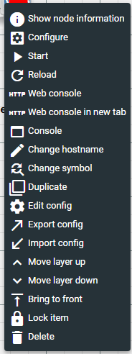

**Map Topology:**

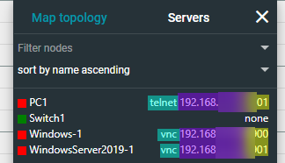

* From left to right
* color indicator for node power state
* node name
* mode of connection
* IP to connect on
* Port to connect with

**TEMPLATES & APPLIANCES**

**Basics:**

* Gns3 uses QEMU virtualization by default (this can be changed with other installations but is likely not worth it)
* One can import templates via gns3a file or make new templates from scratch in the gui
* Templates are what get used in the creation of new gns3 virtual appliances (VAs)

**.gns3a files:**

**Examples:**

**Gns3a files are in a json formant the following is an example of a template using a VMDK file**

"name": "Windows Server 2019",

"category": "guest",

"description": "Microsoft Server VM",

"vendor_name": "Microsoft",

"vendor_url": "http://www.microsoft.com/",

"documentation_url": "https://technet.microsoft.com/en-us/library/cc498727.aspx",

"product_name": "Windows",

"product_url": "https://www.microsoft.com/en-us/windows",

"registry_version": 4,

"status": "stable",

"maintainer": "James Frazer",

"maintainer_email": "james.frazer@mymail.champlain.edu",

"usage": "credentials: Administrator / @dm1n",

"symbol": "microsoft.svg",

"port_name_format": "NIC{port1}",

"qemu": {

"adapter_type": "e1000",

"adapters": 1,

"ram": 2048,

"hda_disk_interface": "sata",

"arch": "x86_64",

"console_type": "vnc",

"boot_priority": "c",

"kvm": "require"

},

"images": [

{

"filename": "WinSer.vmdk",

"version": "WinSer",

"md5sum": "75cabe7597b0b4b460e8c024cfbaac63",

"filesize": 9871163392,

"download_url": "https://www.google.com"

}

],

"versions": [

{

"name": "WinSer",

"images": {

"hda_disk_image": "WinSer.vmdk"

}}]}

**The following is an example of a template using an empty qemu VM and an iso install**

"name": "CentOS",

"category": "guest",

"description": "CentOS",

"vendor_name": "Linux",

"vendor_url": "https://www.centos.org",

"documentation_url": "https://www.centos.org",

"product_name": "CentOS",

"product_url": "https://www.centos.org",

"registry_version": 4,

"status": "stable",

"maintainer": "James Frazer",

"maintainer_email": "james.frazer@mymail.champlain.edu",

"usage": "credentials: root/P@ssw0rd",

"port_name_format": "eth{0}",

"qemu": {

"adapter_type": "e1000",

"adapters": 1,

"ram": 2048,

"hda_disk_interface": "sata",

"arch": "x86_64",

"console_type": "vnc",

"boot_priority": "cd",

"kvm": "allow"

},

"images": [

{

"filename": "CentOS.iso",

"version": "Centos",

"md5sum": "8934d42a86d8589342ac9bdfec82d6b4",

"filesize": 1866465280,

"download_url": "https://www.centos.org"

},

{

"filename": "empty8G.qcow2",

"version": "1.0",

"md5sum": "f1d2c25b6990f99bd05b433ab603bdb4",

"filesize": 197120,

"download_url": "https://sourceforge.net/projects/gns-3/files/Empty%20Qemu%20disk/",

"direct_download_url": "https://sourceforge.net/projects/gns-3/files/Empty%20Qemu%20disk/empty8G.qcow2/download"

}

],

"versions": [

{

"name": "Centos",

"images": {

"hda_disk_image": "empty8G.qcow2",

"cdrom_image": "CentOS.iso"

}}]}

After the import from the GUI edit the template adding the iso you uploaded to the CD/DVD

**Template Web GUI:**

**Creation:**

**Requirement: unlike the import template all files must exists on the GNS3 vm already**

1. From project view click the gns3 logo > Go to preferences > QEMU > add QEMU VM template
2. Run through the creation wizard
3. The VM template will now appear in the QEMU section

**Removeing:**

1. From project view click the gns3 logo > Go to preferences > QEMU > right 3 dots > Delete

**Editing:**

*Editing a templet will not effect already created VAs

1. From project view click the gns3 logo > Go to preferences > QEMU
2. Select the VA of choice
3. Edit any aspect of the VA template the same as you would edit a VA in project view
4. Save

**Standard GNS3 Virtual Appliances:**

* Cloud : acts as a bridged port to the network the GNS3 VM is currently running on
* NAT : acts as a simple 2 port router through the GNS3 VM
  + **DO NOT USE ON THE CHAMPLAIN’s NETWORK**
  + Using a NAT cloud will cause champlains network security to block access to the gns3 VM because of STP use
* Ethernet hub : is a simple hub using only layer 1 and broadcasting messages
* Ethernet switch : is a simple switch using layer 2
* ATM switch : is a simple ATM switch
* Frame Relay switch : is a simple Frame Relay switch
* VPCS : is a light wait computer using a costume Command line OS and can be very useful for network testing.